
CI/CD Pipeline Design Exercise
Intelligent Airport Baggage Tracking and Logistics Management Platform
CSA1016-SOFTWARE ENGINEERING

Name: K.Arthika Reddy
Regno:192373033
Department:CSE(DS)

1. Introduction
The Intelligent Airport Baggage Tracking and Logistics Management Platform is designed to monitor, track, manage, and deliver passenger baggage throughout the airport journey using technologies such as barcode/RFID scanners, IoT sensors, surveillance cameras, GPS/location systems, databases, and AI-based analytics.
The platform can track baggage from check-in to baggage handling, security screening, aircraft loading, transfer, arrival, and final baggage collection.
Since the system handles real-time baggage information and logistics operations, continuous software delivery, automated testing, security validation, reliable deployment, and monitoring are essential.
A CI/CD pipeline is therefore proposed to automate the software development lifecycle from source-code commit to production deployment.

2. CI/CD Requirements Analysis
The system should provide:
- Real-time baggage tracking.
- Baggage status monitoring.
- RFID/barcode-based baggage identification.
- Baggage routing and sorting.
- Flight and baggage association.
- Lost or delayed baggage detection.
- Baggage transfer tracking.
- Real-time notifications.
- Baggage logistics management.
- AI-based anomaly detection.
- Secure communication.
- Scalability for multiple airports.
- High availability.
- Real-time performance.
Therefore, the CI/CD pipeline should provide:
- Automated source-code management.
- Automated application building.
- Unit and integration testing.
- API and database testing.
- AI-model validation.
- Code-quality analysis.
- Security vulnerability scanning.
- Docker container creation.
- Automated deployment.
- Development, staging, and production environments.
- Monitoring and logging.
- Deployment rollback.
- Pipeline success/failure notifications.

3. Proposed CI/CD Pipeline
Developer
|
v
GitHub Repository
|
v
Source Code Commit / Pull Request
|
v
GitHub Actions
|
+----------------------+
| |
v v
Build Dependency Check
| |
+----------+-----------+
|
v
Automated Testing
|
+-------+-------+
| | |
v v v
Unit Integration API
Tests Tests Tests
| | |
+-------+-------+
|
v
Code Quality
SonarQube
|
v
Security Scanning
SAST / Dependency
|
v
Docker Image Build
|
v
Container Image Scan
|
v
Docker Registry
|
v
Staging Deployment
|
v
Acceptance Testing
|
v
Manual Approval
|
v
Production Deploy
|
v
Monitoring + Logging
|
v
Rollback if Failure

4. Tools and Technologies
CI/CD Stage | Tool/Technology | Purpose
Source Code Management | Git | Version control
Repository | GitHub | Store source code
CI/CD | GitHub Actions | Automate pipeline
Frontend | React / Node.js | Build frontend
Backend | Java Spring Boot / Maven | Build backend
Unit Testing | JUnit | Backend testing
Frontend Testing | Jest | Frontend testing
API Testing | Postman/Newman | Test REST APIs
Integration Testing | JUnit/Testcontainers | Test services and database
Code Quality | SonarQube | Static analysis
Security | OWASP Dependency-Check | Vulnerability scanning
Containerization | Docker | Package applications
Registry | Docker Hub/GitHub Container Registry | Store images
Deployment | Docker Compose/Kubernetes | Deploy services
Monitoring | Prometheus | Collect metrics
Visualization | Grafana | Display system metrics
These tools follow the same CI/CD structure used in the uploaded reference, including GitHub Actions, SonarQube, Docker, container scanning, staging, production, monitoring, and rollback.

5. Source Code Management
The GitHub repository can be organized as:
airport-baggage-platform/
│
├── frontend/
├── backend/
├── ai-service/
├── baggage-service/
├── flight-service/
├── tracking-service/
├── logistics-service/
├── notification-service/
├── database/
├── tests/
├── docker-compose.yml
├── Dockerfile
└── .github/
└── workflows/
└── ci-cd.yml
Developers can create feature branches such as:
main
|
+-- feature/baggage-tracking
|
+-- feature/rfid-integration
|
+-- feature/flight-management
|
+-- feature/notification
|
+-- feature/ai-anomaly-detection
A Pull Request is created before changes are merged into the main branch.

6. Build Stage
Backend
For a Spring Boot backend:
mvn clean package
This:
- Downloads dependencies.
- Compiles the application.
- Runs tests.
- Creates the application JAR.
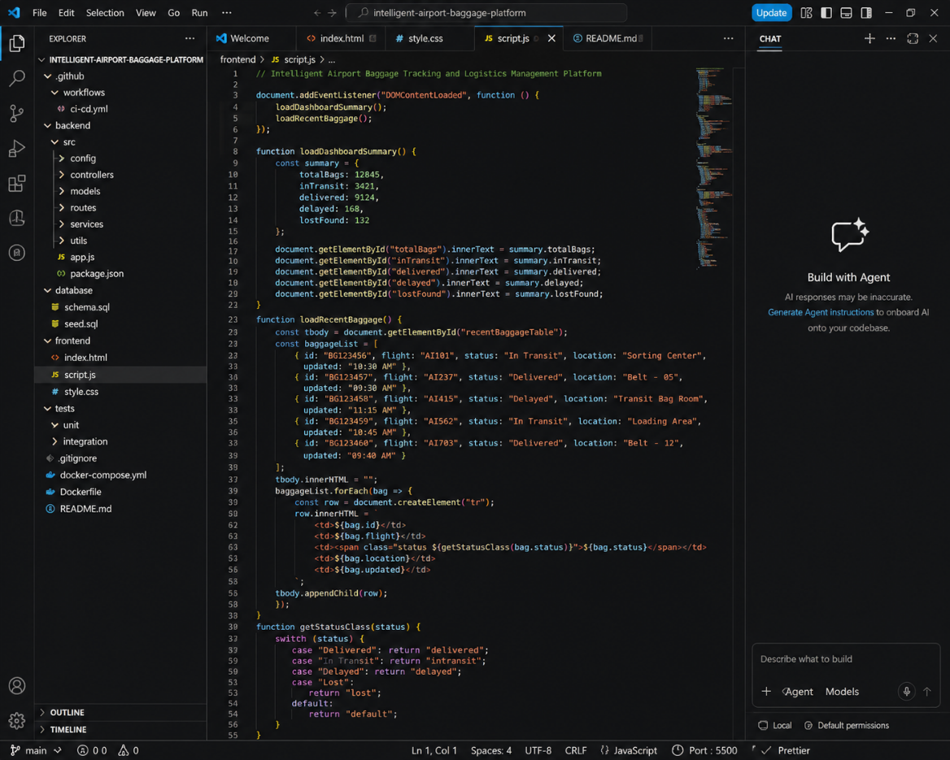
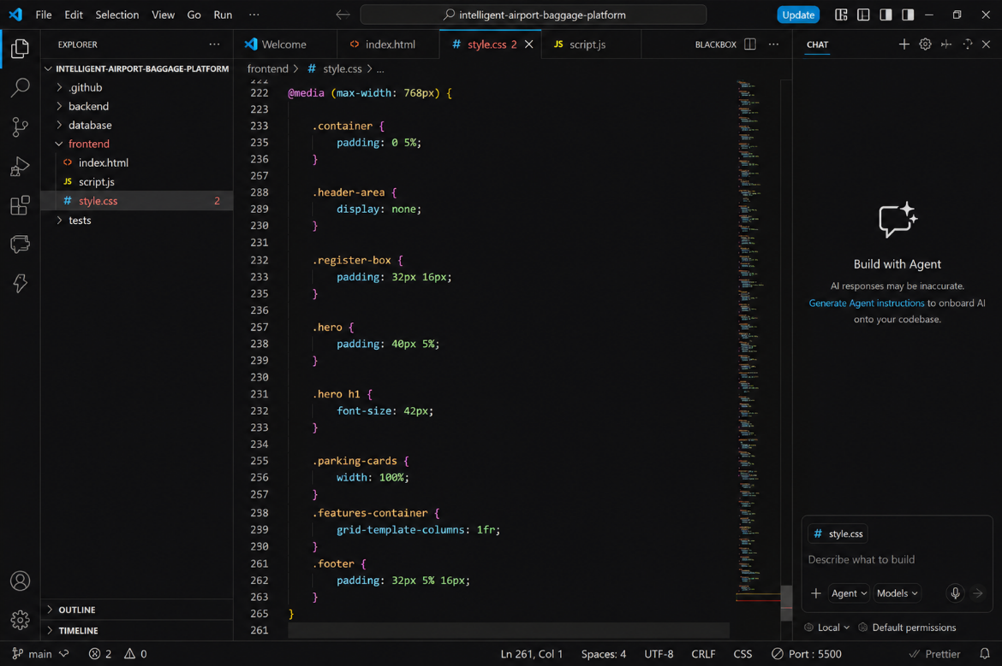

Frontend
For a React frontend:
npm install
npm run build
AI Service
For a Python-based AI service:
pip install -r requirements.txt
pytest
The AI service can then be packaged into a Docker container.
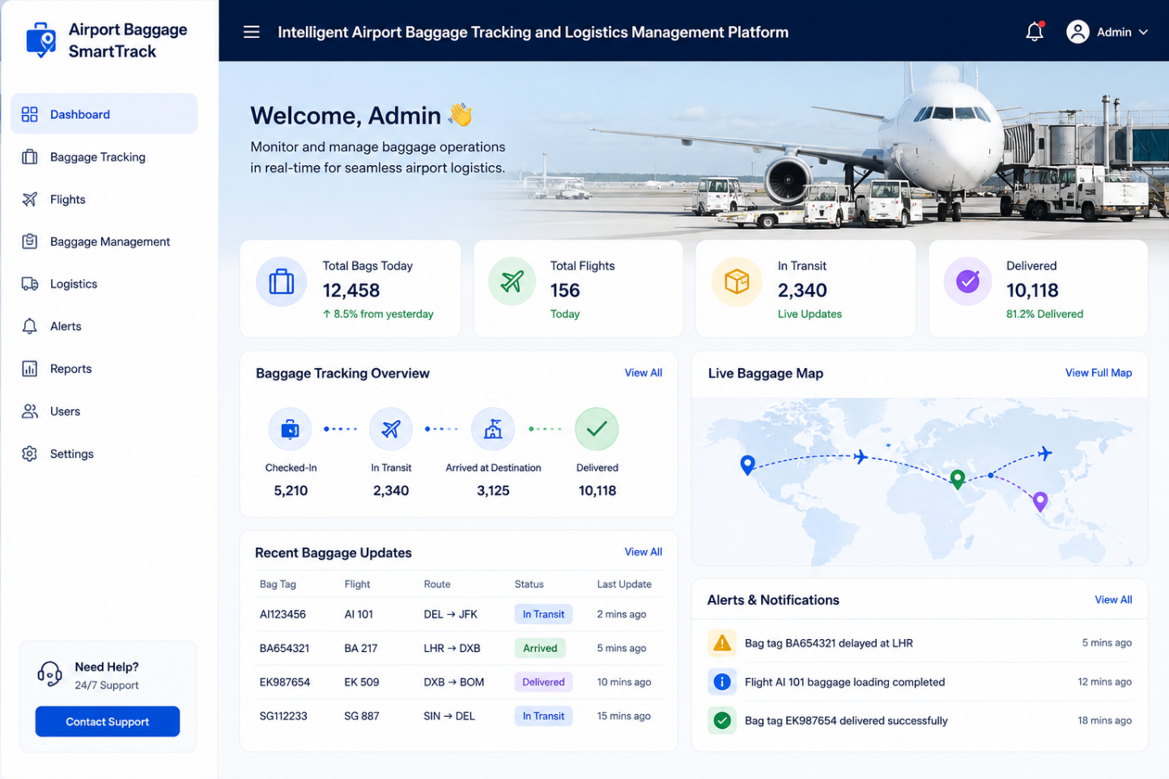
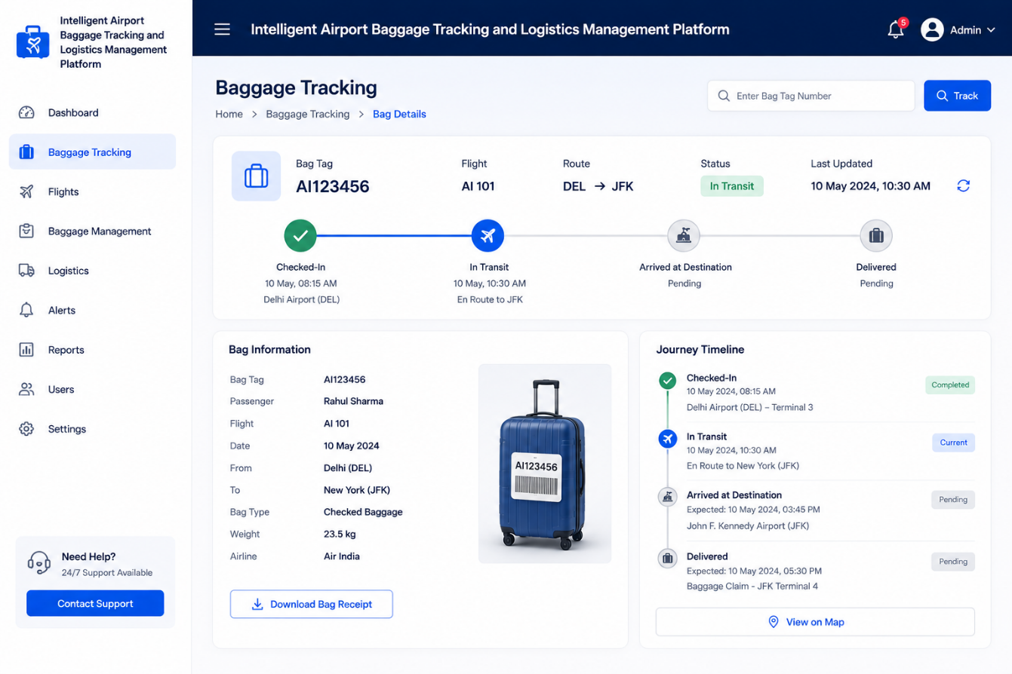
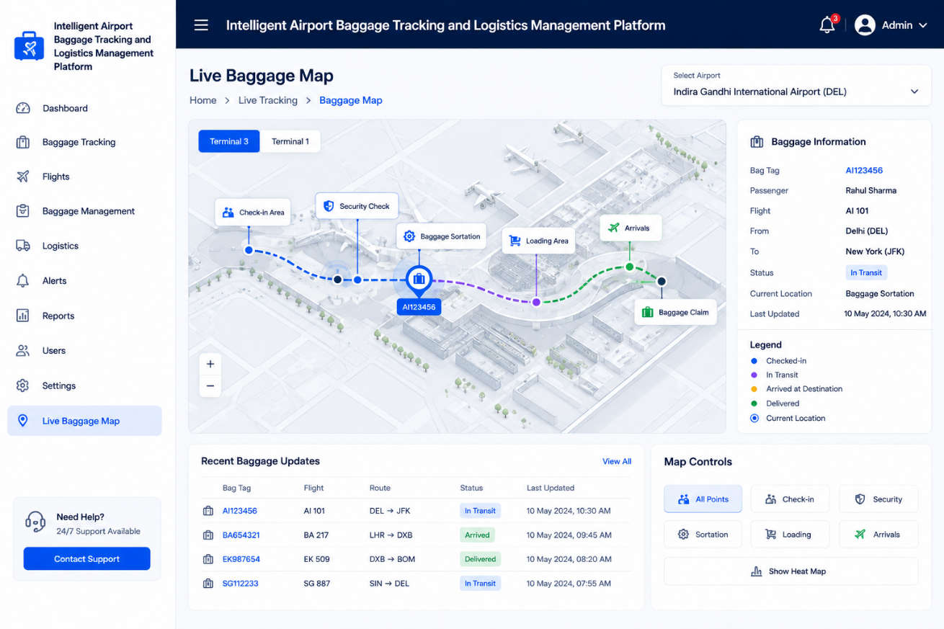

7. Automated Testing Strategy
7.1 Unit Testing
Unit tests verify individual components.
Examples:
- Baggage ID validation.
- Passenger-baggage association.
- Flight assignment.
- Baggage status update.
- RFID data processing.
- Notification generation.
- Lost baggage detection.
- Baggage routing logic.
Example:
Input:
Baggage ID = BG1025
Status = Loaded

Expected:
System displays "Baggage Loaded"
7.2 Integration Testing
Integration testing verifies communication between services.
Baggage Tracking Service
|
v
Database
|
v
Flight Service
|
v
Logistics Service
|
v
AI Service
The tests verify that baggage information is correctly transferred between these components.
7.3 API Testing
Example APIs:
POST /api/login
POST /api/baggage/register
GET /api/baggage/{id}
PUT /api/baggage/{id}/status
GET /api/flights/{id}/baggage
GET /api/baggage/location
POST /api/notifications
The pipeline verifies:
- HTTP status codes.
- Response data.
- Authentication.
- Authorization.
- Error handling.
7.4 Database Testing
Database tests verify:
- Baggage insertion.
- Passenger-baggage association.
- Flight assignment.
- Baggage status updates.
- Location updates.
- Transfer records.
- Transaction consistency.
- Database connection failures.

8. AI Model Testing
The AI component can be used for:
- Lost baggage detection.
- Baggage-routing prediction.
- Delay prediction.
- Abnormal baggage movement detection.
- Logistics optimization.
The pipeline should verify:
- Prediction accuracy.
- Input validation.
- Missing sensor data.
- Model response time.
- Model compatibility.
- Model version.
A model should not be deployed if its validation metrics fall below the predefined threshold.
This follows the reference document's approach of validating AI predictions before deployment.

9. Security Checks
Security is especially important because the platform handles:
- Passenger information.
- Baggage information.
- Flight information.
- Airport operational data.
- Location information.
- RFID/IoT sensor data.
- Authentication credentials.
The CI/CD pipeline should include:
SAST
Scan source code for security vulnerabilities.
Dependency Scanning
Identify vulnerable third-party libraries.
Container Scanning
Scan Docker images for vulnerable packages.
Secret Detection
Ensure passwords, API keys, database credentials, and tokens are not committed to GitHub.
Sensitive information should be stored using secure secret management mechanisms.

10. Docker Containerization
The major services can be packaged into separate containers:
Docker
|
+----------+----------+
| | |
v v v
Frontend Backend AI Service
| | |
v v v
Container Container Container
Additional containers can include:
- Baggage Tracking Service
- Flight Service
- Logistics Service
- Notification Service
- Database
Docker provides consistent environments, dependency isolation, portability, and easier deployment.

11. Deployment Environments
Development
Used for:
- Feature development.
- Debugging.
- Initial testing.
Developer → Git → Development
Staging
The staging environment should closely replicate production.
CI Pipeline
|
v
Staging
|
v
Integration Testing
|
v
Acceptance Testing
Production
The production environment contains the live airport baggage platform.
Staging
|
v
Approval
|
v
Production
Only successfully tested and approved versions should reach production.

12. Deployment Strategy
A rolling deployment can be used.
Instead of updating all services simultaneously, new versions are gradually deployed.
Instance 1 → New Version
Instance 2 → Old Version
Instance 3 → Old Version

↓

Instance 1 → New Version
Instance 2 → New Version
Instance 3 → Old Version

↓

Instance 1 → New Version
Instance 2 → New Version
Instance 3 → New Version
This reduces downtime and allows baggage operations to continue during deployment.

13. Rollback Mechanism
Rollback is required if the new version causes problems such as:
- Application crashes.
- Incorrect baggage status.
- API failures.
- Database errors.
- Incorrect baggage location.
- AI prediction failure.
- High error rate.
- Security vulnerabilities.
Production Deployment
|
v
Health Check
/ \
PASS FAIL
| |
v v
Continue Rollback
|
v
Previous Version
The reference similarly recommends health checks followed by rollback to the previous stable version when deployment fails.

14. Monitoring and Logging
After deployment, the system should continuously monitor:
- CPU utilization.
- Memory utilization.
- API response time.
- Number of baggage-tracking requests.
- Error rate.
- Database performance.
- Service availability.
- RFID/IoT data processing.
- Baggage-processing delays.
Prometheus can collect metrics and Grafana can visualize them.

15. Complete CI/CD Workflow
DEVELOPER
|
v
GitHub Repository
|
v
Pull Request / Push
|
v
GitHub Actions
|
v
BUILD
|
v
AUTOMATED TESTING
|
+---- Unit Tests
+---- API Tests
+---- Integration Tests
+---- Database Tests
+---- AI Model Tests
|
v
CODE QUALITY
|
v
SonarQube
|
v
SECURITY SCANNING
|
v
DOCKER BUILD
|
v
CONTAINER SCAN
|
v
DOCKER REGISTRY
|
v
STAGING DEPLOYMENT
|
v
ACCEPTANCE TESTING
|
v
MANUAL APPROVAL
|
v
PRODUCTION DEPLOYMENT
|
v
HEALTH CHECK
|
/ \
PASS FAIL
| |
v v
LIVE ROLLBACK
|
v
MONITORING

16. Quality Gates
Gate | Condition | Action
Build Gate | Application builds successfully | Continue
Unit Test Gate | Required tests pass | Continue
Integration Gate | Services communicate correctly | Continue
Code Quality Gate | SonarQube criteria pass | Continue
Security Gate | No critical vulnerabilities | Continue
Container Gate | Docker image is secure | Continue
Staging Gate | Acceptance tests pass | Continue
Production Gate | Authorized approval | Deploy
Health Gate | Production health checks pass | Continue/Rollback
The uploaded reference uses the same quality-gate concept to prevent failed builds, poor-quality code, security issues, or unhealthy deployments from reaching production.

17. Benefits
Faster Development
Automated builds and testing reduce manual effort.
Improved Software Quality
Automated testing identifies baggage-tracking and logistics errors early.
Improved Security
Security scanning detects vulnerabilities before production.
Reliable Deployment
Automated deployment reduces human errors.
Reduced Downtime
Rolling deployment and rollback improve system availability.
Scalability
Docker and Kubernetes can support multiple airports and baggage-handling services.
Real-Time Reliability
Monitoring helps identify failures in baggage tracking and logistics services quickly.
Continuous Improvement
Frequent integration and automated feedback allow developers to continuously improve the platform.

18. Conclusion
The proposed CI/CD pipeline provides an automated and reliable approach for developing and deploying the Intelligent Airport Baggage Tracking and Logistics Management Platform.
The pipeline integrates GitHub, GitHub Actions, automated testing, SonarQube, security scanning, Docker, container registries, staging, production deployment, monitoring, and rollback mechanisms.
By implementing this CI/CD approach, the baggage-management platform can achieve better software quality, security, reliability, scalability, faster deployment, and reduced downtime. These characteristics are particularly important for an airport system that continuously processes real-time baggage, passenger, flight, and logistics information.

